

CSE422 Project Report

Career Switch Prediction Using Supervised Machine Learning and K-Fold Cross Validation

Submitted By:
- Mir Mohammad Sajedul Islam {ID: 23201376}

Table of Contents

1 | Introduction | 3
2 | Dataset Description | 3
3 | Imbalanced Dataset Analysis | 6
4 | Exploratory Data Analysis (EDA) | 7
5 | Dataset Pre-processing | 8
6 | Dataset Splitting | 8
7 | Model Training & Testing (Supervised Learning) | 9
8 | Unsupervised Learning (K-Means Clustering) | 10
9 | Model Selection and Comparison Analysis | 10
10 | K-Fold Cross Validation | 12
11 | Conclusion | 13

1. Introduction

Identifying whether a data scientist is actively looking for a job change is a critical task for HR departments aiming to optimize recruitment strategies. Early detection of a candidate's intent allows organizations to reduce recruitment costs and improve retention.
The objective of this project is to develop a machine learning–based career switch prediction system using a real-world HR dataset. The project focuses on analyzing candidate demographics, education, and experience, performing proper data preprocessing, and applying multiple supervised learning models to predict whether a candidate will change careers. Additionally, K-Fold Cross Validation is used to evaluate the robustness and generalizability of the models. Both supervised and unsupervised learning approaches are explored to gain deeper insights into the dataset.

2. Dataset Description
- Dataset Overview:
The dataset used in this project is an HR dataset containing candidate demographics, lifestyle, and corporate attributes relevant to career switch detection.

- Number of Features:
The dataset consists of 13 input features and 1 output feature.

- Classification or Regression Problem:
This is a binary classification problem because the target variable will_change_career has two possible values:

0 → Will Not Change Career
1 → Will Change Career The goal is to classify candidates into one of these two categories.
- Number of Data Points:
The dataset contains roughly 19,000 data points (rows), each representing an individual candidate record.

- Types of Features:

- Quantitative (Numerical) Features:
city_development_index, training_hours
- Categorical Features:
gender, relevent_experience, enrolled_university, education_level, major_discipline, experience, company_size, company_type, last_new_job

      - Quantitative (Numerical) Features
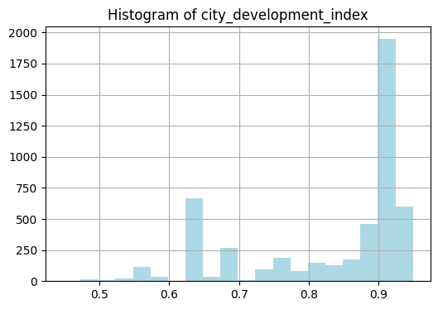 |  | 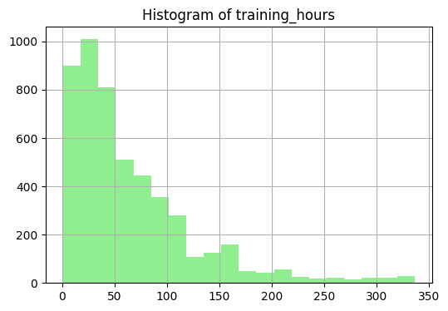
2. Categorical Features:
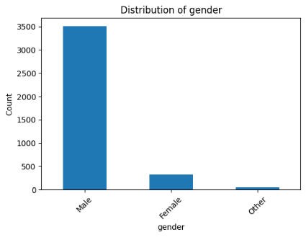 | 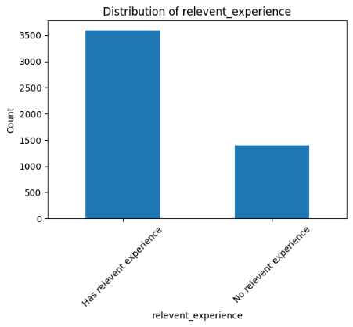 |  | 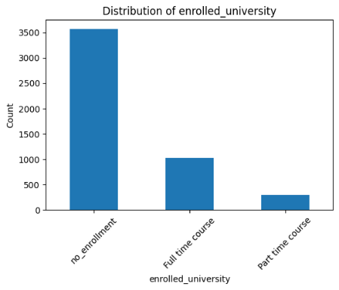
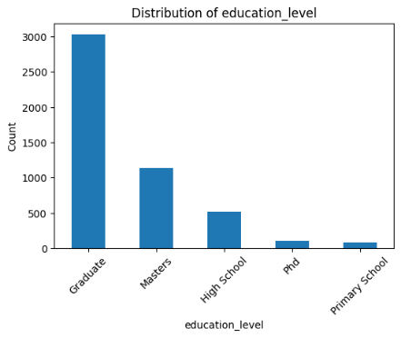 | 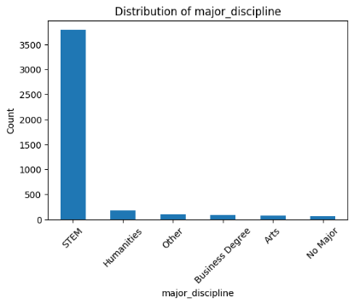 |  | 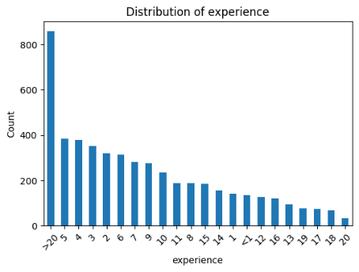
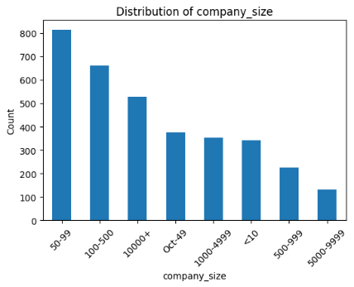 | 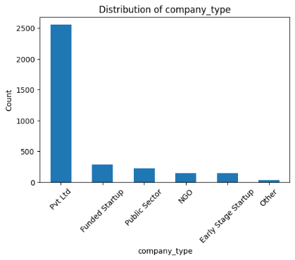 |  | 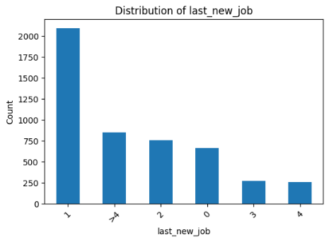

Encoding of Categorical Variables

Categorical variables cannot be directly processed by machine learning algorithms. Therefore, for categorical variables like gender, education_level, and company_size, encoding techniques such as Label Encoding and One-Hot Encoding were applied to convert these categorical features into numerical representations during preprocessing.

Correlation Analysis

A correlation heatmap was generated to analyze relationships between the numerical features and the career switch outcome (will_change_career).

Interpretation of Correlation Test

The correlation analysis shows that city_development_index has the strongest correlation with a candidate's intent to change careers (showing a negative correlation, meaning candidates in cities with a lower development index are more likely to seek new job opportunities). The training_hours feature shows a much weaker correlation, indicating it is not a strong standalone predictor. However, no single feature is sufficient to predict a career switch independently, justifying the use of complex machine learning models to learn the overlapping relationships across all demographic and experience factors.

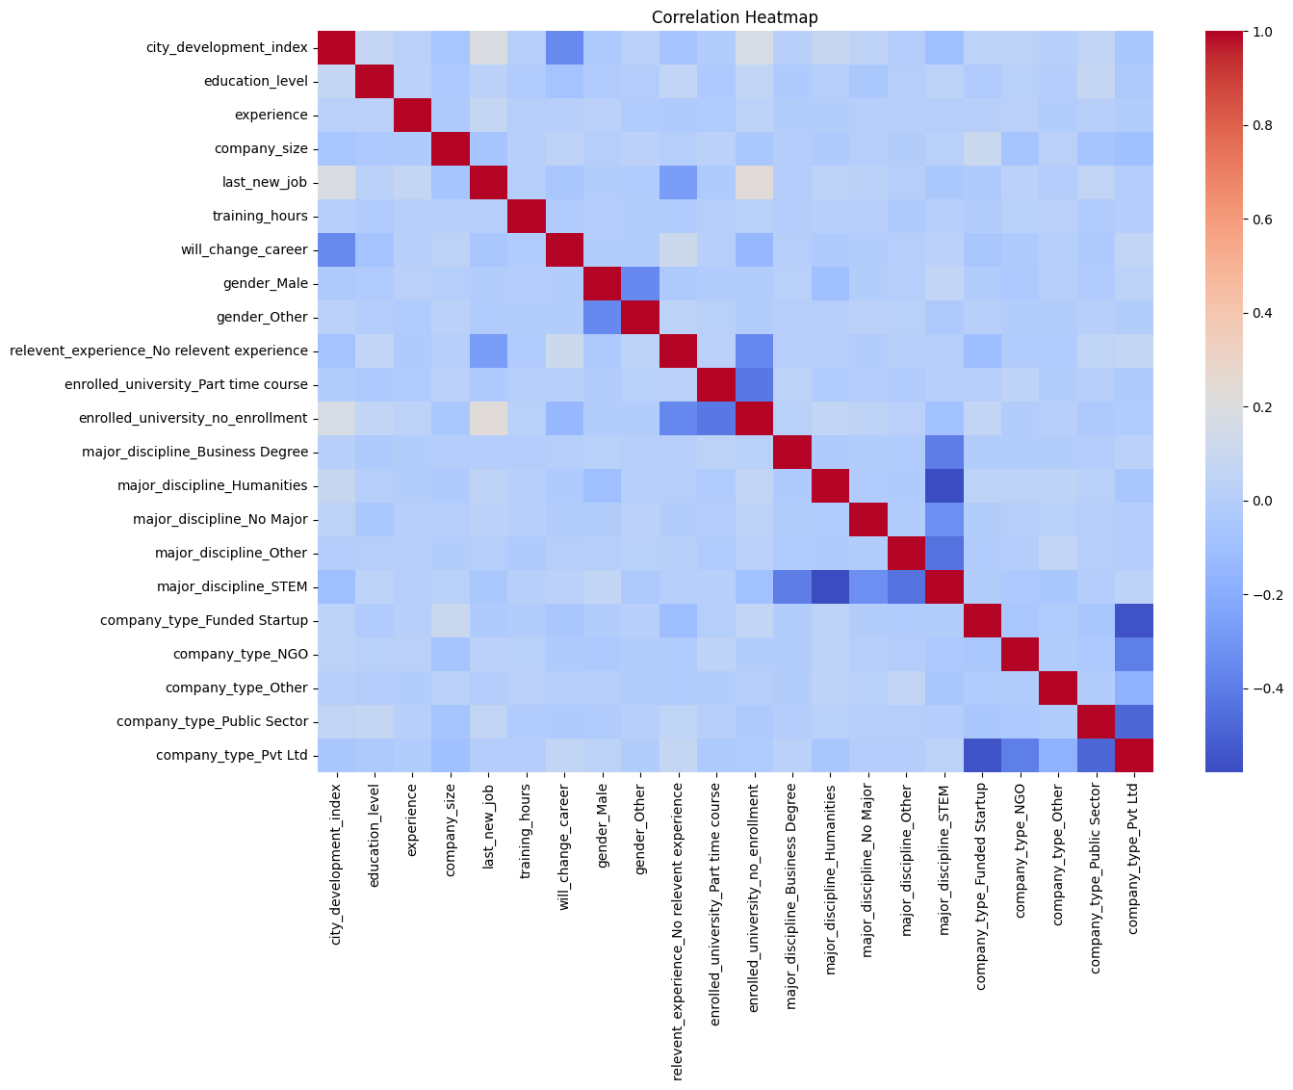

3. Imbalanced Dataset Analysis

The target variable, will_change_career, is imbalanced, meaning the number of candidates not looking to change careers is significantly higher than those looking to switch.

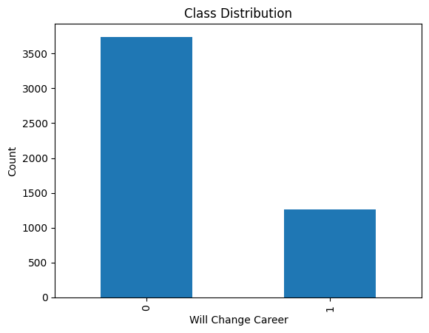

- Implications:
Class imbalance can cause models to favor the majority class. Therefore, evaluation metrics such as precision, recall, F1-score, and AUC were emphasized instead of relying only on accuracy.
- Solution:
To mitigate the effects of class imbalance, the project explored techniques such as setting class_weight='balanced' within the Logistic Regression model. Furthermore, the model's decision threshold was analyzed via the ROC Curve to prioritize Recall, ensuring that the model minimizes False Negatives when detecting candidates looking to leave.

4. Exploratory Data Analysis (EDA)

Exploratory Data Analysis was performed to understand the dataset structure, detect anomalies, and identify meaningful patterns. Key EDA steps included:

- Visualization of numerical feature distributions using histograms
- Detection of outliers using boxplots
- Analysis of career change occurrence across city_development_index and training_hours.
- Feature–target relationship analysis
- Categorical feature distribution analysis
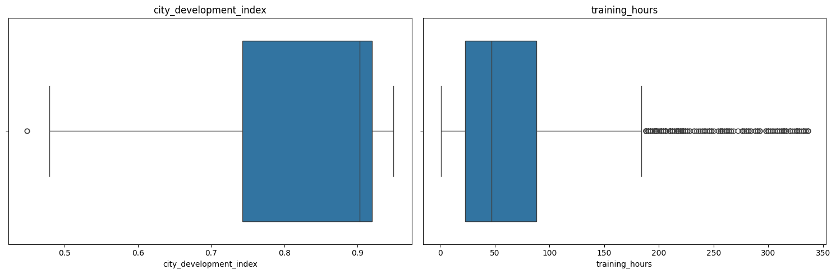

Key Findings:

- Candidates looking for a job change generally have different spreads across the city development index.
- training_hours feature has a heavily right-skewed distribution.
- Outliers exist in the numerical features, but were retained as they represent valid cases.

5. Dataset Pre-processing

Identified Problems and Solutions

1. Missing Values: Some features contained missing values.
Solution:
- Numerical features → Median imputation
- Categorical features → Mode imputation

2. Categorical Variables: Categorical features were unsuitable for direct model input.
Solution:
- Label Encoding for ordinal features (education_level, experience, company_size, last_new_job).
- One-Hot Encoding (get_dummies) for remaining nominal features.
3. Feature Scaling: Numerical features had different ranges.
Solution:
- Standardization using StandardScaler.

6. Dataset Splitting

The dataset was split using a stratified train–test split to preserve class distribution:
- Training Set: 80%
- Testing Set: 20%
Stratification ensures both sets maintain similar proportions of career-changing and non-changing cases.

7. Model Training & Testing (Supervised Learning)

In accordance with the project requirements, a Neural Network was used as a mandatory supervised learning model along with two additional classification algorithms. The selected models are Logistic Regression, K-Nearest Neighbors (KNN), and a Neural Network (Multilayer Perceptron).

- Logistic Regression was used as a baseline model due to its simplicity and interpretability. It estimates the probability of a career switch using a linear combination of input features and performs well in binary classification problems.
- K-Nearest Neighbors (KNN) was selected to capture non-linear patterns in the data without making assumptions about feature relationships. It classifies candidates based on similarity to neighboring data points. An Elbow Method curve was plotted to find the optimal K value. Feature scaling was applied due to KNN’s sensitivity to distance.
- Neural Network (Multilayer Perceptron) was chosen as the primary model because it can learn complex non-linear relationships and interactions among features.
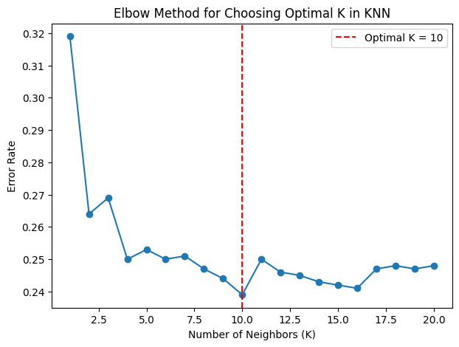

8. Unsupervised Learning (K-Means Clustering)

K-Means clustering is an unsupervised learning algorithm that groups data points based on similarity without using the target variable. It identifies natural structures in the data by minimizing the distance between data points and cluster centroids. An elbow graph was plotted to justify the optimal number of clusters based on WCSS (Within-Cluster Sum of Square).

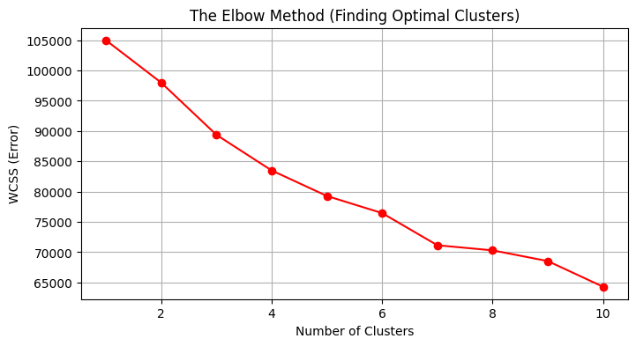

9. Model Selection and Comparison Analysis

Evaluation Metrics Used:
- Accuracy: Represents the proportion of correctly classified instances. Can be misleading when the dataset is imbalanced.
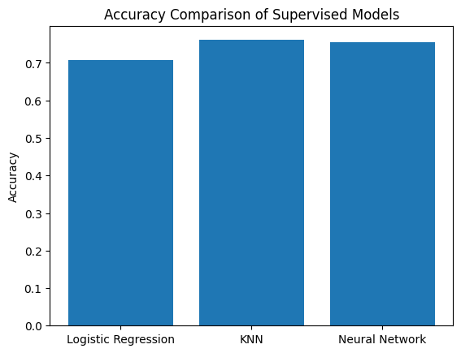

- Precision: Measures the proportion of correctly predicted switch cases among all cases predicted as switching. Helps assess false positives.
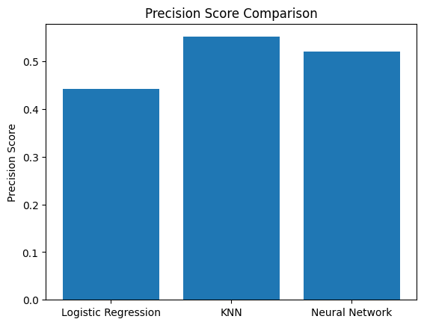

- Recall (Sensitivity): Measures the proportion of actual switch cases correctly identified. Important because failing to detect a leaving candidate (false negative) has business consequences.
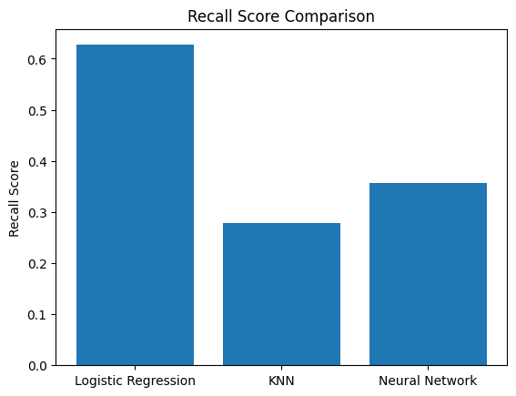

- F1-Score: The harmonic mean of precision and recall. Provides a balanced measure.
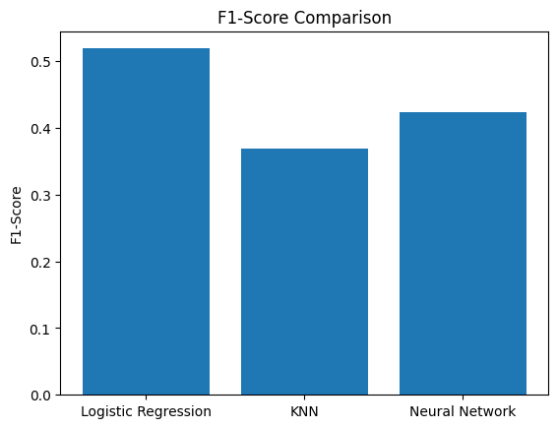

- Confusion Matrix: Summarizes classification results showing true positives, true negatives, false positives, and false negatives.
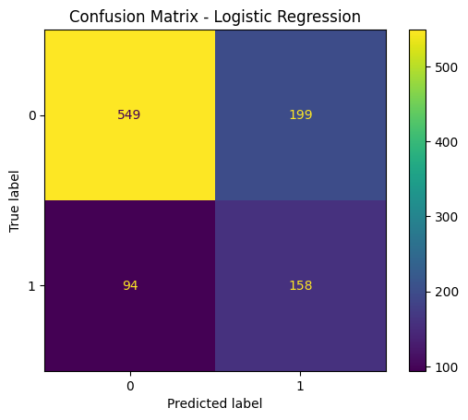 | 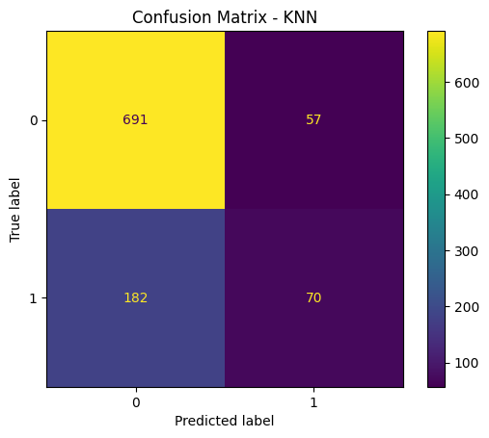 | 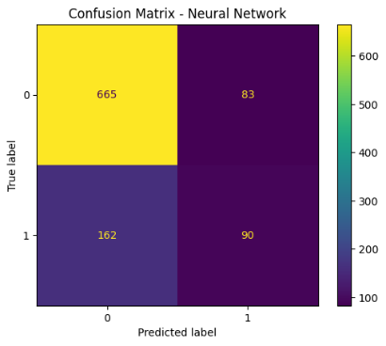

- ROC Curve & AUC: Illustrates trade-off between true positive rate and false positive rate. Higher AUC indicates better discriminative capability.
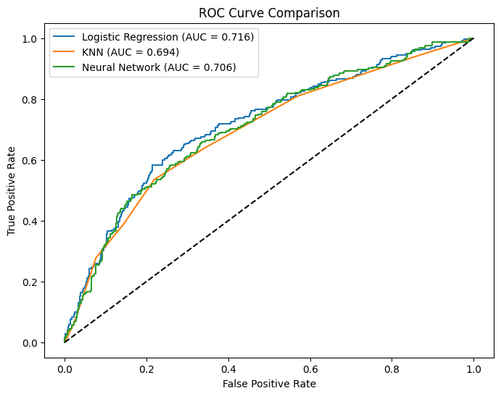

Key Insight: The cross-validation results showed consistent performance across all folds, indicating that the model does not rely on a specific train-test split. This confirms the robustness of the model and reduces the risk of overfitting.

10. K-Fold Cross Validation

K-Fold Cross Validation was applied to evaluate the stability and generalizability of the trained models. In this method, the dataset was divided into 5 equal folds, and the model was trained and tested five times, each time using a different fold as the test set while the remaining folds were used for training. Stratified K-Fold was used to preserve the class distribution in each fold.
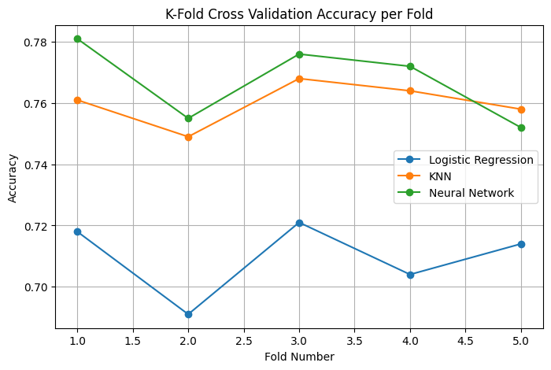

11. Conclusion

Our project confirms that machine learning can accurately identify career switch intent by analyzing key demographic and corporate markers. While all our models performed well, the Neural Network and KNN stood out as capable algorithms. This suggests that the indicators of a career change have complex, overlapping relationships that deep learning and distance-based approaches handle well.

The primary challenge was the significant class imbalance in the dataset—since there were far fewer switch cases than non-switch cases, we had to look beyond "Accuracy" and focus on Recall and Precision, applying class_weight='balanced' where applicable. Data cleaning also required careful attention, particularly handling missing values using median and mode imputation without losing the integrity of the data. Finally, using K-Fold cross validation gave us high confidence that our models are stable and applicable to real-world HR data.

